**Energy balance for the Engine**

We will make a variable load test for the engine. All sensors are connected to the engine and all indicators are working.

**Procedure:**

1. Start the engine

2. Open the throttle valve until the speed reach 1000 rpm

3. Wait while the engine is running until you reach steady state

4. Read all the data shown in the table from the indicators

5. Repeat the same procedures with load varying between (0, 5, 10, 15, and 20)lb

|  |  |  |  |  |  |  |  |  |  |
| --- | --- | --- | --- | --- | --- | --- | --- | --- | --- |
| No | Speed(rpm) | Load  (Ib) | Hcw  (mm) | Tc,i  © | Tc,o | Hw_air | Tex | Vfuel  (ml) | Time  (sec) |
| 1 | 1000 | 0 | 7.8 | 33 | 34 | 1.2 | 45 | 50 | 90 |
| 2 | 1000 | 5 | 7.8 | 37 | 39 | 1.2 | 65 | 50 | 81 |
| 3 | 1000 | 10 | 7.8 | 41 | 43 | 1.2 | 75 | 50 | 63 |

# Equations:

1-mf*Q=Bp+Qcool+Qexhaust+Qsurrounding

2-Fp=mf*Qhv

3-Bp=(load*N)*0.746/2800

4-Qcool=mc*cp*(Tc,o-Tc,i)

5-mc=0.0533292*sqrt(h)

6-Qexh=me*Cpexh*(Tex-Tamb)

7-me=mair+mfuel

8-mair=densityair*Cd*Ao*sqrt(2*g*hw*density water/densityair)

|  |  |  |  |  |  |  |  |  |  |  |  |  |  |  |  |  |
| --- | --- | --- | --- | --- | --- | --- | --- | --- | --- | --- | --- | --- | --- | --- | --- | --- |
|  | Fuel Energy | | | | DYNO. | Cooling Losses | | | | | Exhaust Losses | | | | |  |
| N (rpm) | Vol (ml) | Time(sec) | Mf*(kg/sec) | FP (kj) | BP (kW) | h | mcw* | Tin | Tout | Q  cool | h | Mair* | Mex* | Tex | Qexh. | Q surr |
| 1000 | 50 | 90 | 4.611*10^-4 | 19.87 | 0 | 7.8 | 0.1489 | 33 | 34 | 0.623 | 1.2 | 0.15 | 0.15 | 45 | 3.39 | 15.857 |
| 50 | 81 | 5.123*10^-4 | 22.1 | 1.332 | 7.8 | 0.1489 | 37 | 39 | 1.25 | 1.2 | 0.15 | 0.15 | 65 | 6.78 | 12.738 |
| 50 | 63 | 6.587*10^-4 | 28.4 | 2.664 | 7.8 | 0.1489 | 41 | 43 | 1.25 | 1.2 | 0.15 | 0.15 | 75 | 8.475 | 16 |

Percentage of different types of power at a given load:

At load=10 lb and N=1000 rpm

Percentage of brake power= $\frac{brake power}{fuel power}=9.38\%$

Percentage of cooling losses= $\frac{cooling losses}{fuel power}=4.4\%$

Percentage of exhaust losses= $\frac{exhaust losses}{fuel power}=29.8\%$

Percentage of surrounding losses= $\frac{surrounding losses}{fuel power}=\frac{14.767}{20.140}×100=56.33\%$

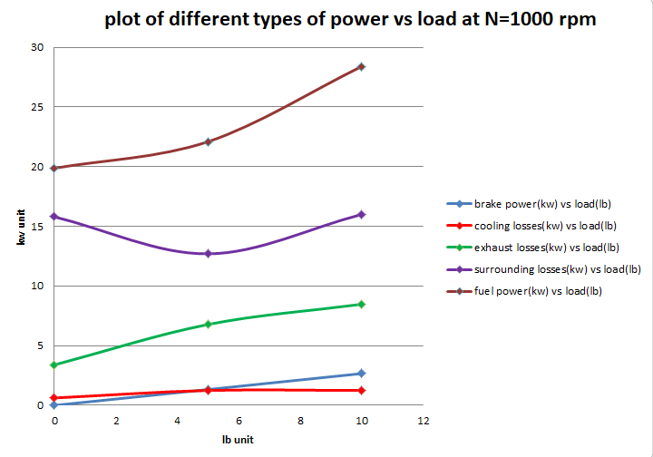

Constants used:

Qhv = 43.1 Mj/kg

Fuel density = 830

Cp water = 4.187

Cp ex = 1.13

Cd= 0.658

Ao=0.001353

Density air = 1.23

**Comment:** 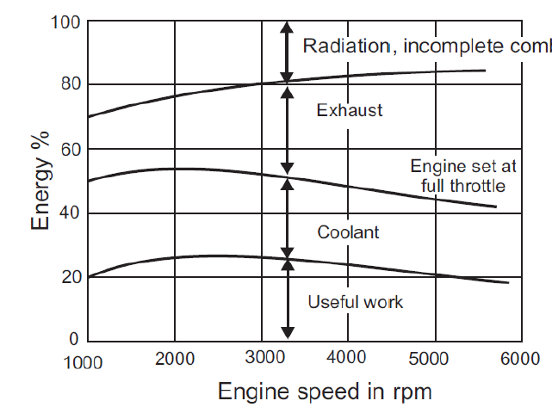

From the above results we see that the percentage of fuel lost differs according to the load as the load increases the percentage of power lost increases the percentage of energy lost will help in finding new methods to improve the performance of the engine in terms of efficiency and the power output.

**But** there is a huge error in this results comparing with the real results where this experiment is done in old machine and with old measuring instruments so we suffered from the incomplete combustion smell in the lab this lead to huge error and other measuring instruments weren’t in right position and much problems in having the readings due to wet floor.